# INF10025 Data Management and Analytics

# Task 4 – Credit Submission

Student Number: 104071453  
Student Name: Marco Giacoppo

### Credit 4a

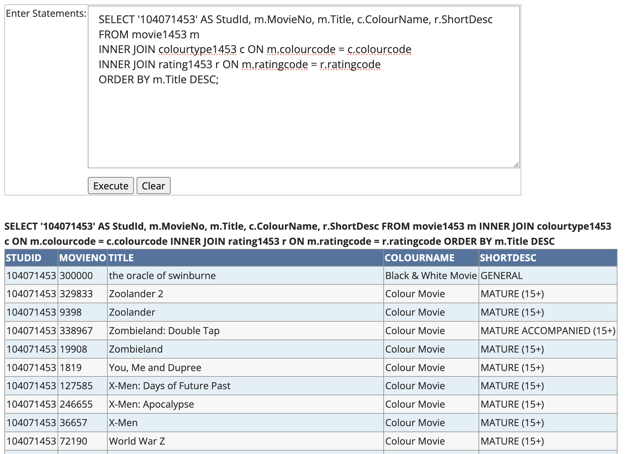

### Credit 4b

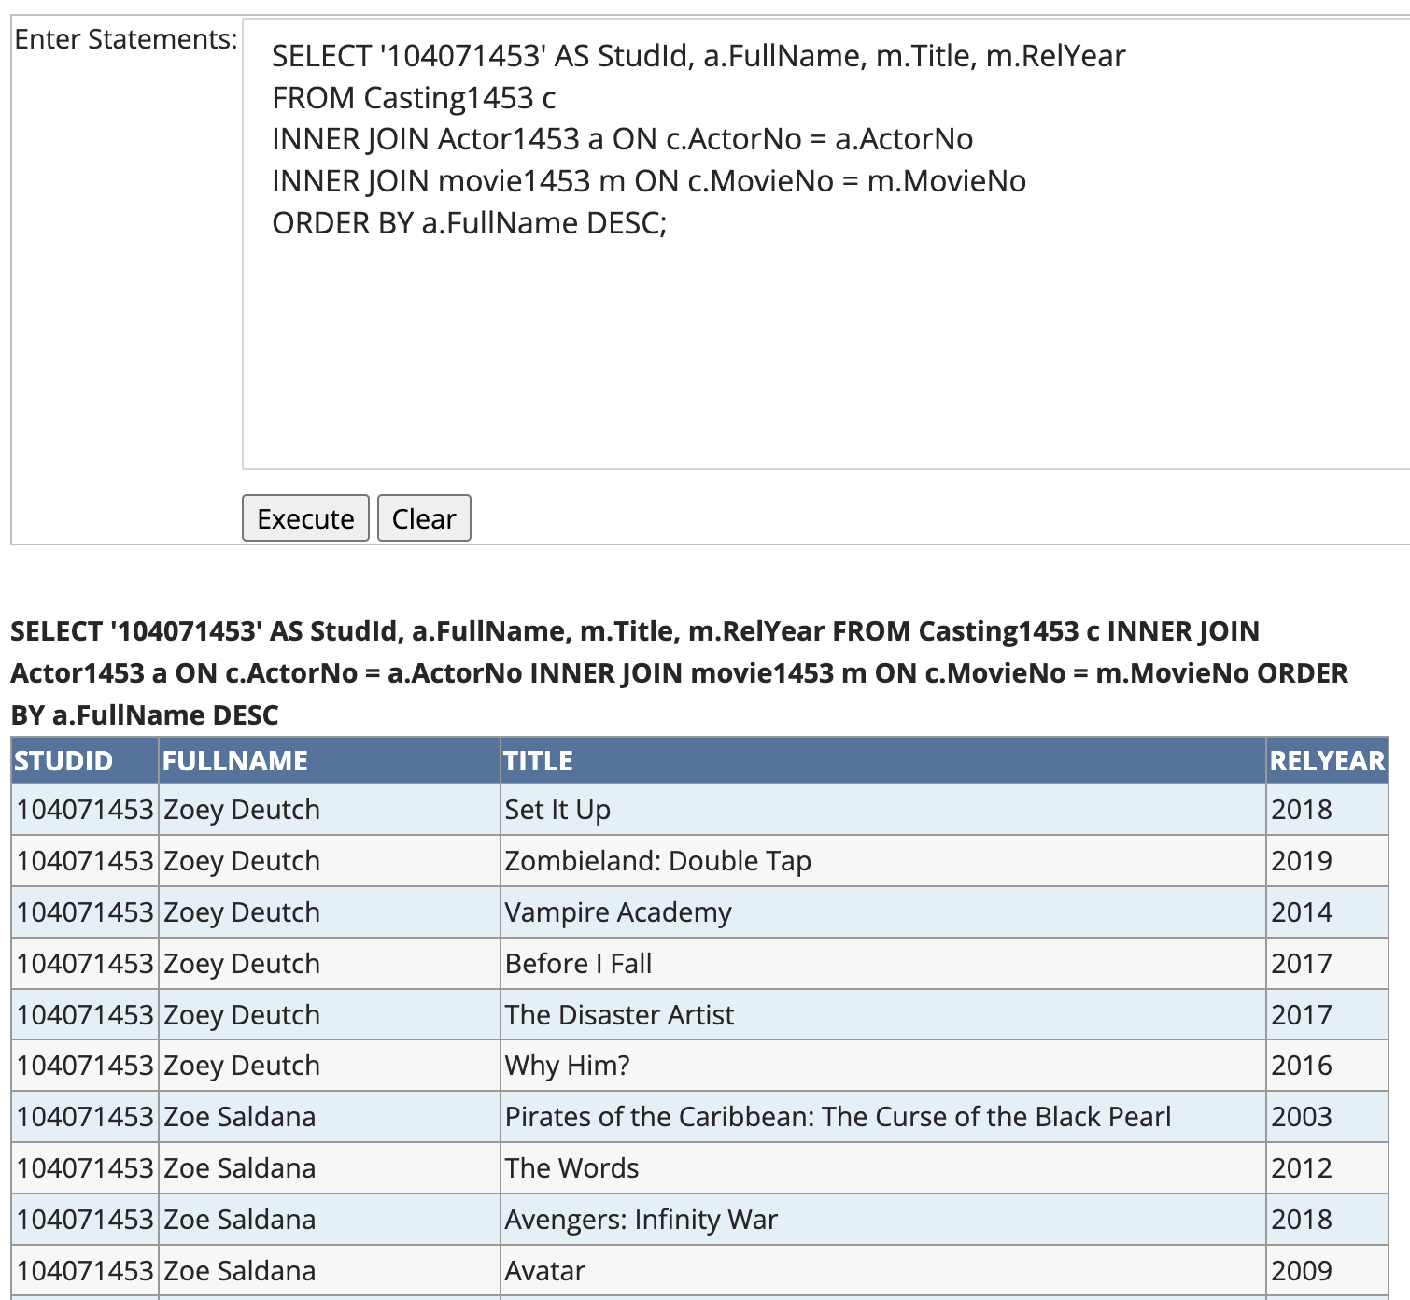

### Credit 4c

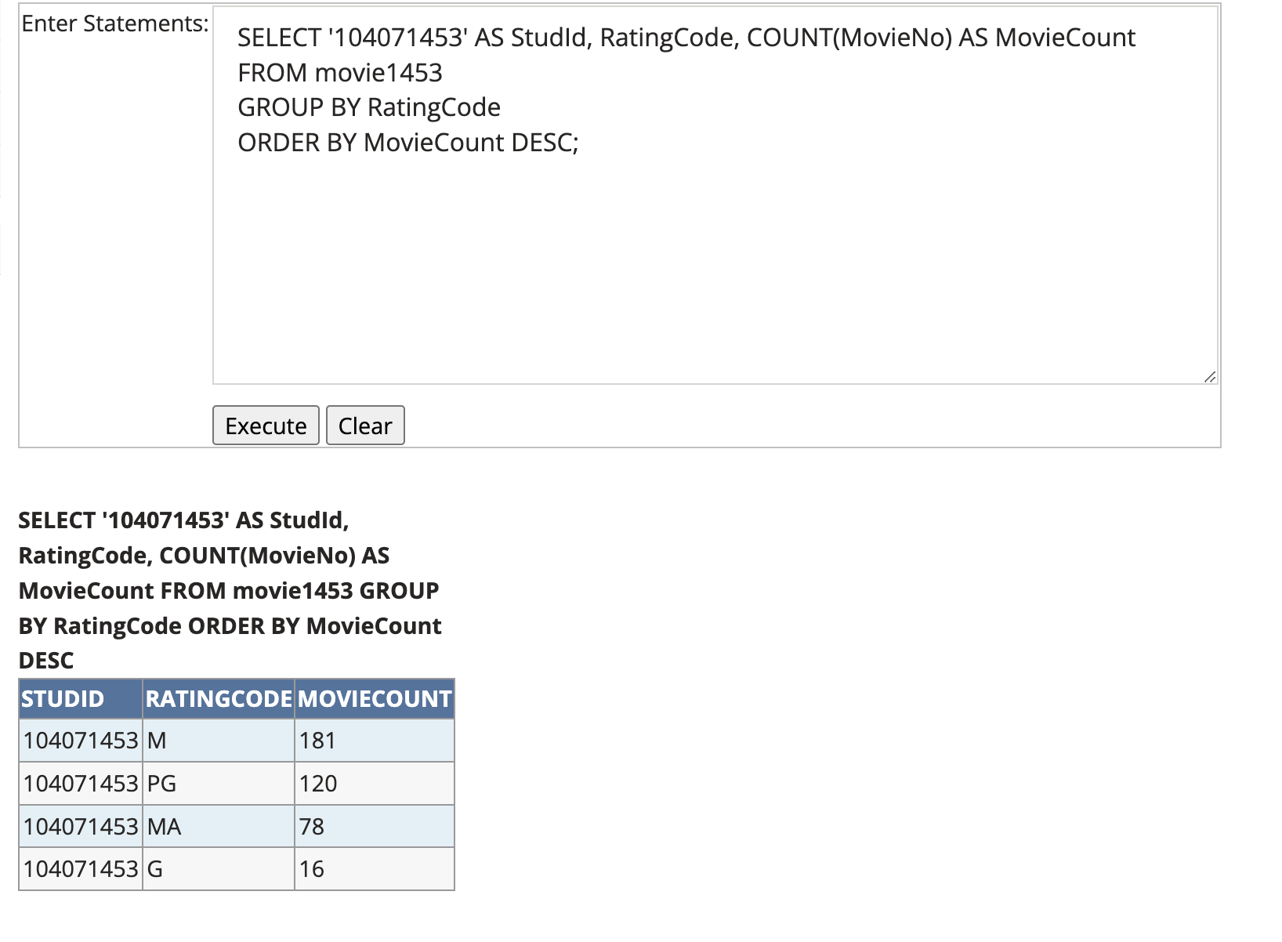

### Credit 4d

### Credit 4e

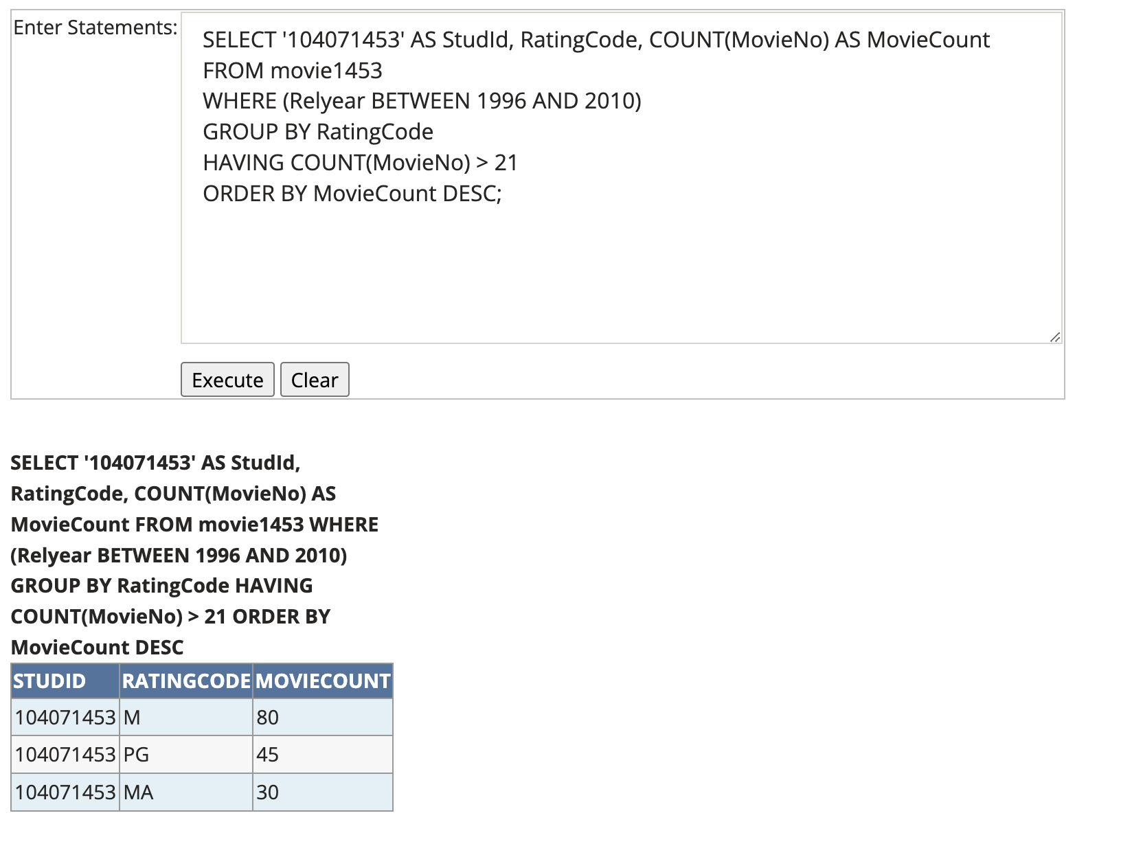

### Credit 4f

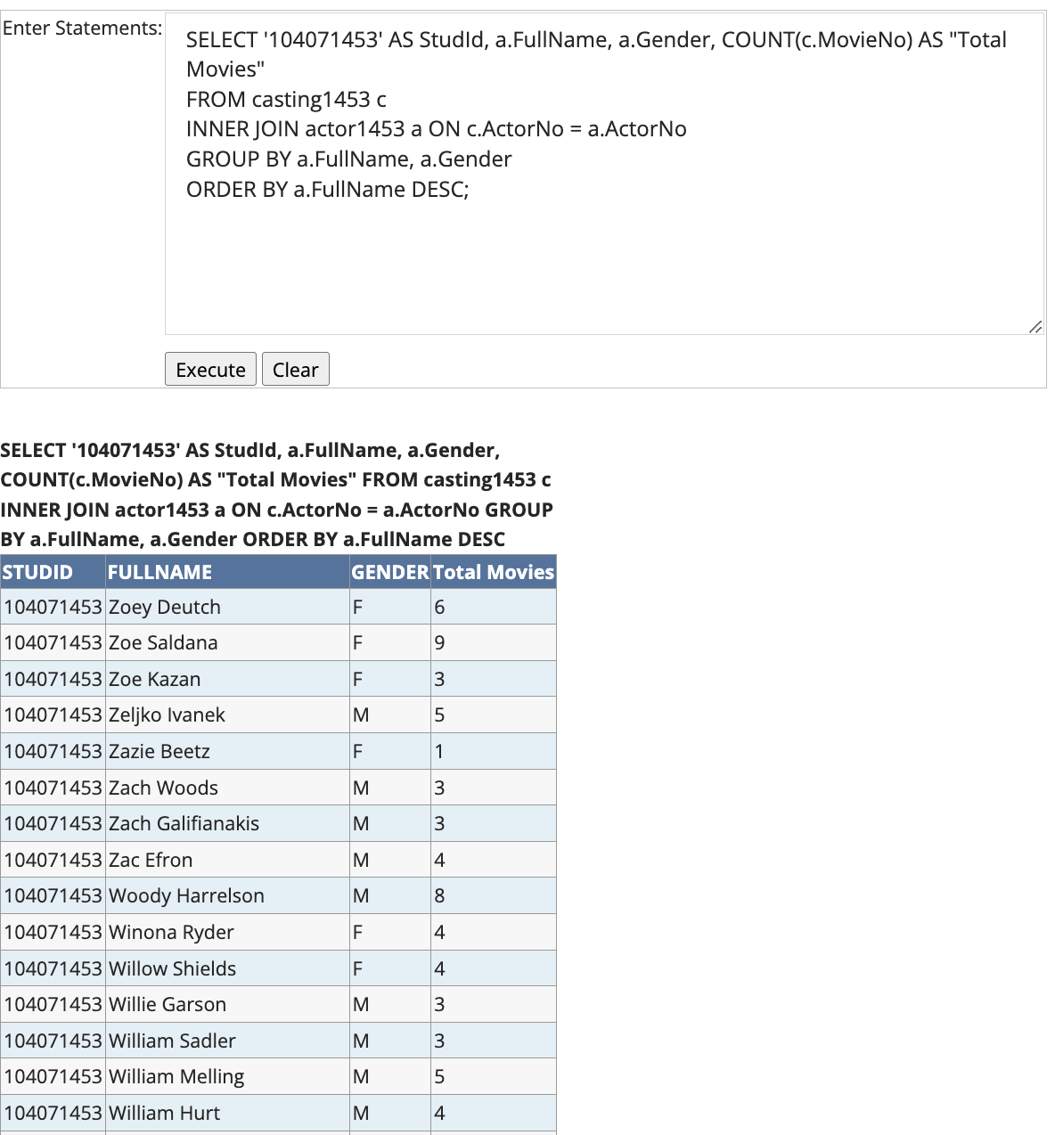

### Credit 4g

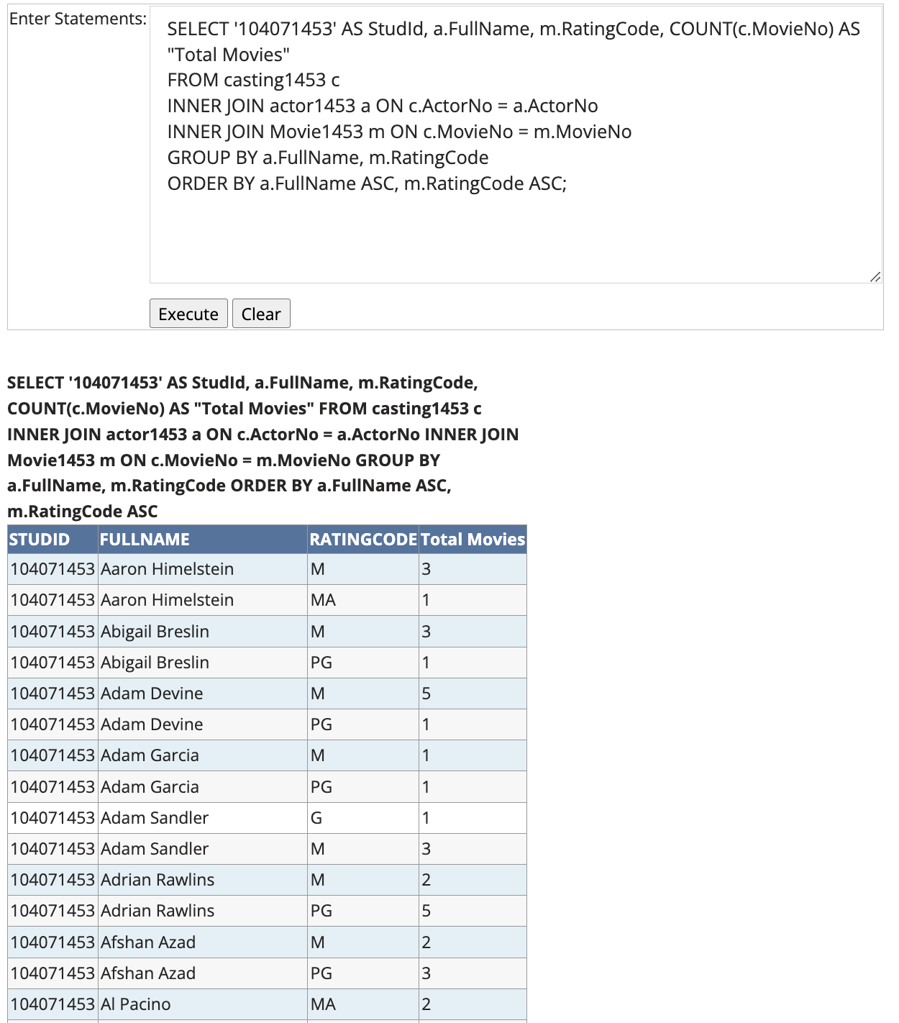

### Credit 4h

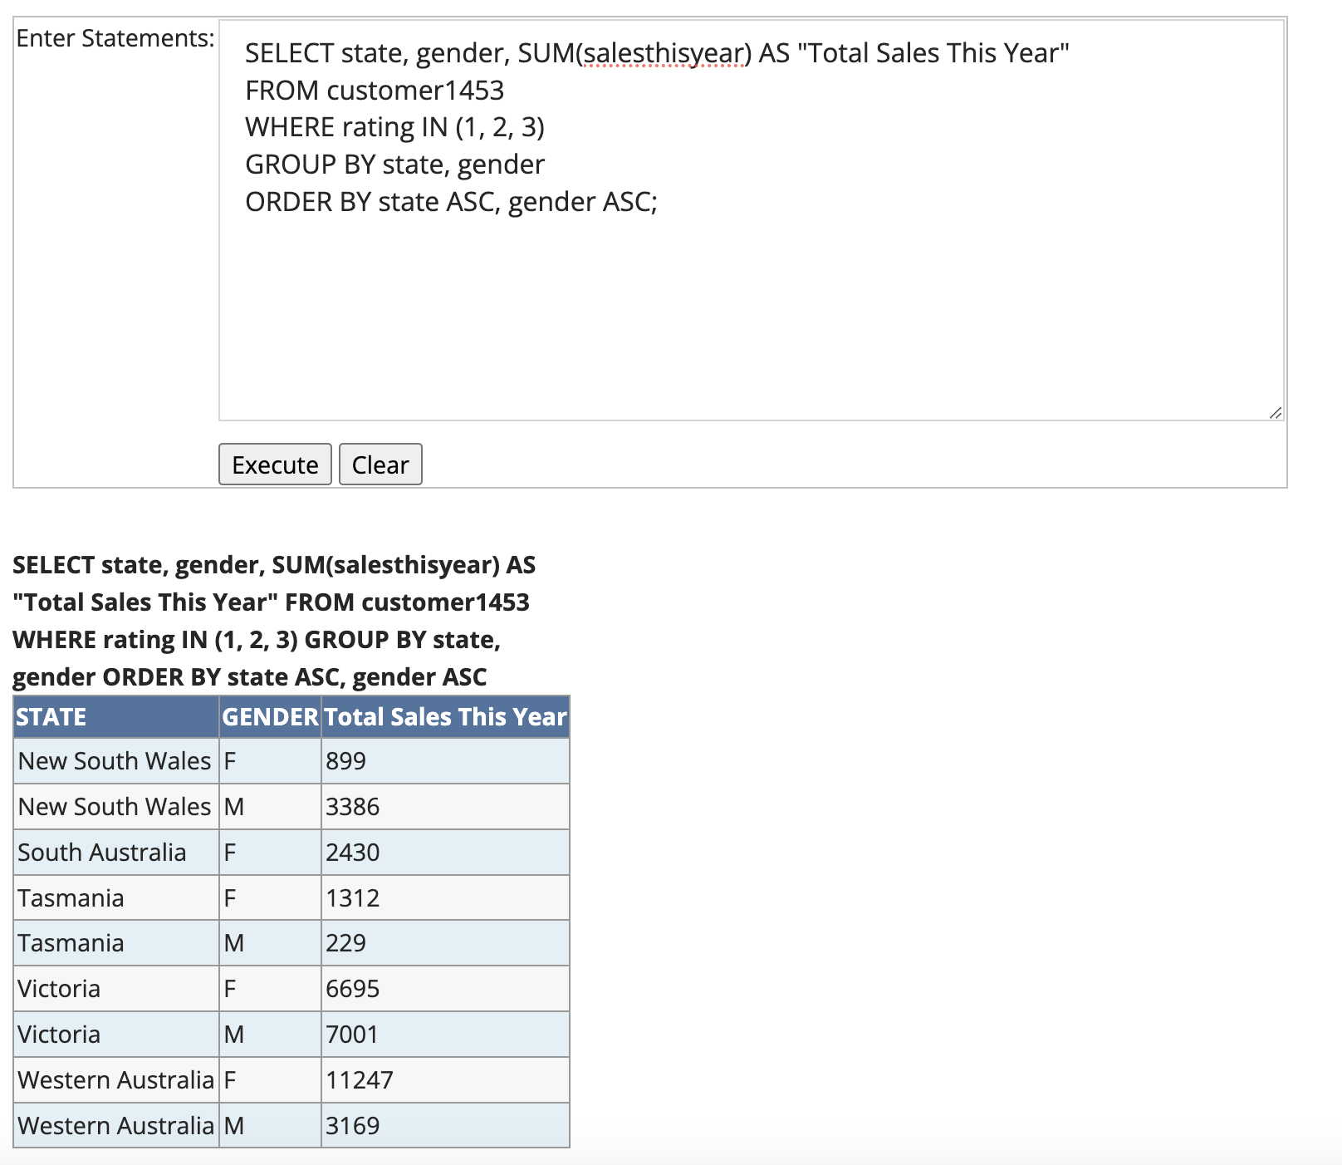

The total sales by state and gender shows that the males generally contribute more to sales in states like New South Wales and Victoria. However, in states like Western Australia, females contribute significantly more to total sales. Tasmania also shows a significant difference.